Decision tree
Q1) Briefly discuss the Decision Tree algorithm with an example and proper derivation.
Ans:-
Decision Tree Algorithm (5 Marks Answer)
A Decision Tree is a supervised machine learning algorithm used for classification and regression tasks. It represents decisions in a tree-like structure where:
- Each internal node represents a test on a feature,
- Each branch represents an outcome of the test,
- Each leaf node represents a class label (decision).

Working Principle
The algorithm follows a top-down greedy approach known as recursive binary splitting:
- Start with the full dataset as the root.
- Select the best feature to split the data.
- Partition the dataset based on that feature.
- Repeat the process recursively for each subset until:
  - All samples belong to the same class, or
  - No further meaningful split is possible.

Derivation using Entropy and Information Gain
To choose the best feature, Decision Trees (like ID3) use Entropy and Information Gain.
Entropy (measure of impurity):
$$H(S)=-\sum_{i=1}^{c}{p_{i}}{log⁡}_{2}p_{i}$$
where $p_{i}$is the probability of class $i$.
$$H(S)=-\sum_{i=1}^{c}{p_{i}}{log⁡}_{2}p_{i}$$
Information Gain (reduction in entropy):
$$IG(S,A)=H(S)-\sum_{v∈Values(A)}{\frac{∣S_{v}∣}{∣S∣}}H(S_{v})$$
$$IG(S,A)=H(S)-\sum_{v∈Values(A)}{\frac{∣S_{v}∣}{∣S∣}}H(S_{v})$$
- Choose the attribute with maximum Information Gain for splitting.

Example
Consider a dataset for Play Tennis:
Outlook | Play
Sunny | No
Sunny | No
Overcast | Yes
Rain | Yes
Step 1: Calculate Entropy of dataset
- Yes = 2, No = 2
$$H(S)=-\left(\frac{2}{4}{log⁡}_{2}\frac{2}{4} + \frac{2}{4}{log⁡}_{2}\frac{2}{4}\right)=1$$
Step 2: Split on Outlook
- Sunny → (No, No) → Entropy = 0
- Overcast → (Yes) → Entropy = 0
- Rain → (Yes) → Entropy = 0
So,
$$IG(S,Outlook)=1-0=1$$
Hence, Outlook is the best attribute and becomes the root.

Final Tree
Outlook
/ | \
Sunny Overcast Rain
No Yes Yes

Conclusion
Decision Trees are simple, interpretable, and effective models that use Information Gain (or Gini Index) to select optimal splits. However, they may suffer from overfitting, which can be reduced using pruning techniques.
Q2)
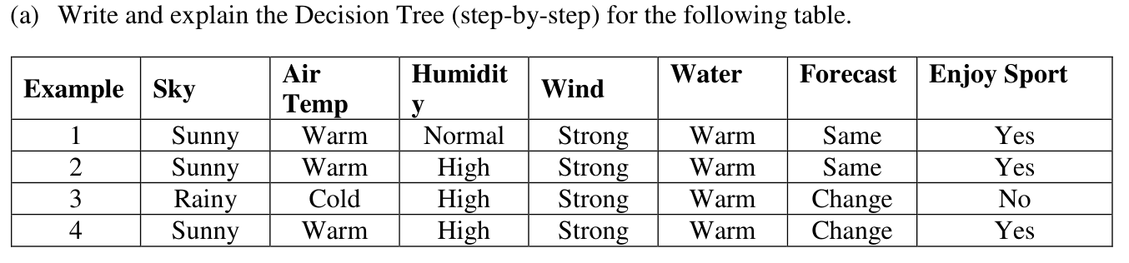
Ans:-
(a) Decision Tree Construction (Step-by-Step using ID3 Algorithm)
Given dataset:
Example | Sky | Air Temp | Humidity | Wind | Water | Forecast | Enjoy Sport
1 | Sunny | Warm | Normal | Strong | Warm | Same | Yes
2 | Sunny | Warm | High | Strong | Warm | Same | Yes
3 | Rainy | Cold | High | Strong | Warm | Change | No
4 | Sunny | Warm | High | Strong | Warm | Change | Yes

Step 1: Calculate Entropy of Dataset
Total samples = 4
Yes = 3, No = 1
$$H(S)=-\left(\frac{3}{4}{log⁡}_{2}\frac{3}{4} + \frac{1}{4}{log⁡}_{2}\frac{1}{4}\right) \\ H(S)=-(0.75{log⁡}_{2}0.75+0.25{log⁡}_{2}0.25)≈0.811$$

Step 2: Compute Information Gain for Each Attribute

1. Attribute: Sky
- Sunny → (Yes, Yes, Yes) → Entropy = 0
- Rainy → (No) → Entropy = 0
$$IG(S,Sky)=0.811-0=0.811$$

2. Attribute: Air Temp
- Warm → (Yes, Yes, Yes) → Entropy = 0
- Cold → (No) → Entropy = 0
$$IG(S,AirTemp)=0.811$$

3. Attribute: Humidity
- High → (Yes, No, Yes) → Entropy ≈ 0.918
- Normal → (Yes) → Entropy = 0
$$IG(S,Humidity)=0.811-\left(\frac{3}{4}×0.918+\frac{1}{4}×0\right) \\ IG≈0.811-0.688=0.123$$

4. Attribute: Forecast
- Same → (Yes, Yes) → Entropy = 0
- Change → (No, Yes) → Entropy = 1
$$IG(S,Forecast)=0.811-\left(\frac{2}{4}×0+\frac{2}{4}×1\right) \\ IG=0.811-0.5=0.311$$

5. Attributes: Wind, Water
- All values are same → Entropy does not change
$$IG=0$$

Step 3: Choose Best Attribute
Maximum Information Gain = 0.811
Best attributes: Sky or Air Temp
(We select Sky as root node)

Step 4: Split on Sky

Case 1: Sky = Sunny
All outputs = Yes → Leaf node = Yes

Case 2: Sky = Rainy
All outputs = No → Leaf node = No

Final Decision Tree
Sky
/ \
Sunny Rainy
Yes No

Conclusion
The Decision Tree is constructed using Information Gain.
The attribute Sky perfectly classifies the dataset in a single split, resulting in a pure tree with zero entropy at leaf nodes, ensuring maximum accuracy.

Q3)
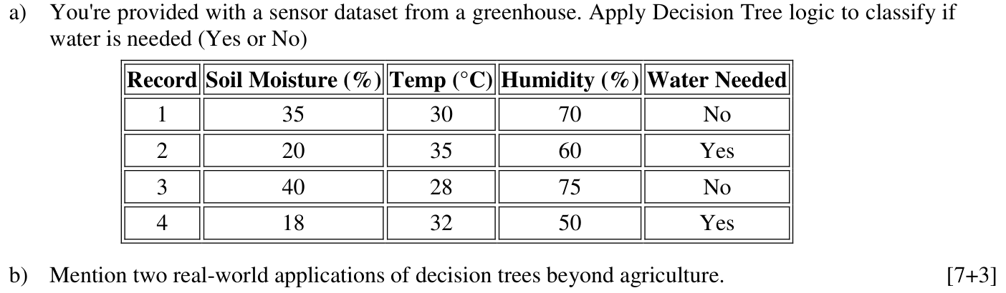
Ans:-
(a) Decision Tree Construction for “Water Needed” (7 Marks)
Given dataset:
Record | Soil Moisture (%) | Temp (°C) | Humidity (%) | Water Needed
1 | 35 | 30 | 70 | No
2 | 20 | 35 | 60 | Yes
3 | 40 | 28 | 75 | No
4 | 18 | 32 | 50 | Yes

Step 1: Analyze Target Variable
Total samples = 4
Yes = 2, No = 2
$$H(S)=-\left(\frac{2}{4}{log⁡}_{2}\frac{2}{4} + \frac{2}{4}{log⁡}_{2}\frac{2}{4}\right)=1$$

Step 2: Choose Best Attribute (Observation-Based Splitting)
Here attributes are continuous, so we choose suitable thresholds.

1. Soil Moisture
Sort values: 18, 20, 35, 40
Possible split: Soil Moisture ≤ 25
- ≤ 25 → (20,18) → Yes, Yes → Entropy = 0
- 25 → (35,40) → No, No → Entropy = 0
$$IG(S,SoilMoisture)=1-0=1$$
This perfectly separates the data.

Step 3: Construct Decision Tree
Root Node: Soil Moisture ≤ 25
- If Soil Moisture ≤ 25 → Water Needed = Yes
- If Soil Moisture > 25 → Water Needed = No

Final Decision Tree
Soil Moisture ≤ 25
/ \
Yes No
(Water Needed) (Water Needed)

Conclusion
The attribute Soil Moisture provides maximum information gain and perfectly classifies the dataset in a single split. Hence, it is selected as the root node.

(b) Two Real-World Applications of Decision Trees (3 Marks)
- Medical Diagnosis
Decision Trees are used to classify diseases based on symptoms, test results, and patient history (e.g., predicting diabetes or heart disease).
- Financial Risk Analysis (Loan Approval)
Banks use Decision Trees to decide whether to approve loans by analysing income, credit score, and repayment history.

Q4)
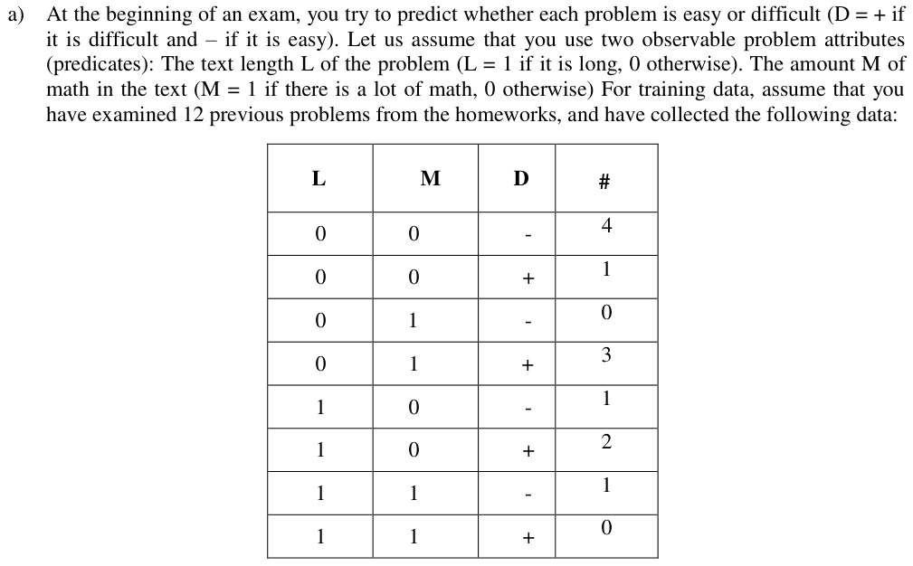
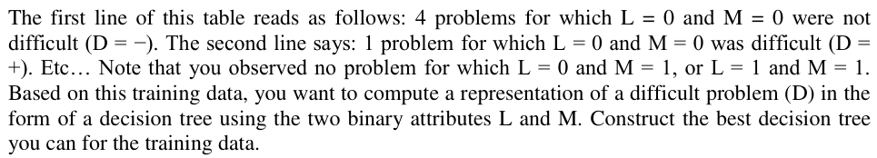
Ans:-

Q5)
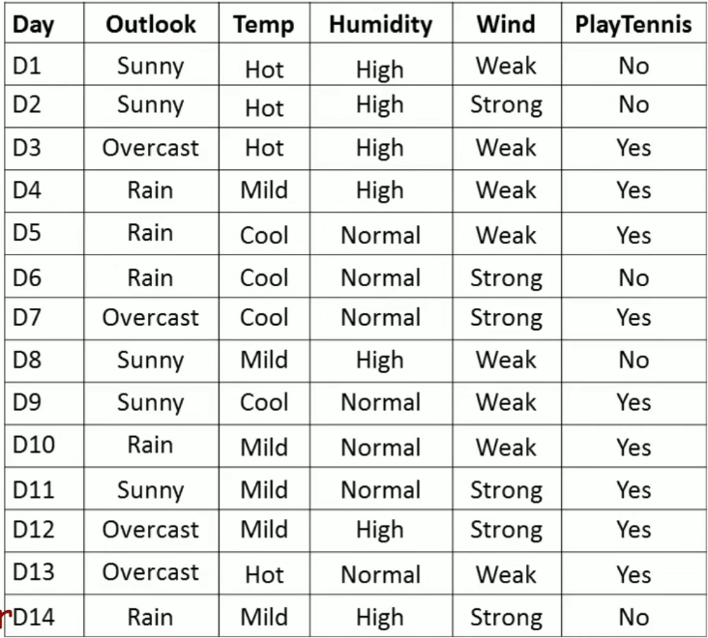
Ans:-
